**1. Basic Information**

* **Name:** Mr. Niraj Kumar Sahu
* **Designation:** Assistant Professor
* **Department/School:** Information Technology
* **Institution Name:** SSIPMT Raipur
* **Email ID:** n.sahu@ssipmt.com
* **Contact Number:** 8770387386
* **Photograph:**

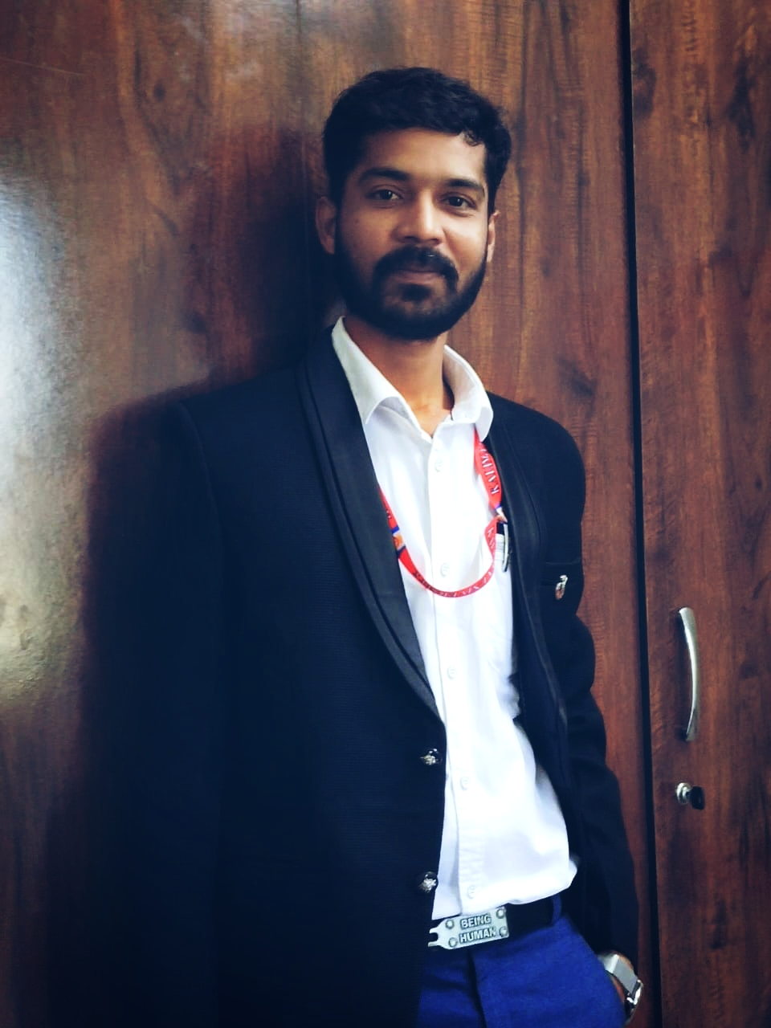

2. **Educational Qualifications**

|  |  |  |  |
| --- | --- | --- | --- |
| Degree | Specialization | Institution | Year of Completion |
| UG | Computer Science & Engineering | CSIT, Durg | 2008 |
| PG | Computer Technology & Application | SSCET, Bhilai | 2015 |
| Ph.D. | - | - | - |
| Others | *(if applicable)* |  |  |

3. **Teaching & Research Experience**

* Total Teaching Experience: **13+**
* Industry Experience: *(if any):****1***
* Research Experience:**05**

4. **Courses Taught**

* **List of key UG/PG courses taught :** DBMS, Data Mining ,Data Structures, Cloud Computing, Computer Network, Computer Graphics, Software Engineering, Operation Research

5. **Research Interests / Specialization**

* Key thematic areas or domains of expertise: Data Science, Artificial Intelligence, Image Processing, Networking.

6. **Publications (Last 5 Years)**

* Journals (APA/IEEE format): **10**
* Conference Proceedings : **02**
* Book Chapters / Books Authored : **NIL**

7. Research Guidance

|  |  |  |
| --- | --- | --- |
| Level | Awarded | Ongoing |
| Ph.D. | NIL | NIL |
| PG | NIL | NIL |

8. **Awards & Recognitions**

* Institutional / National / International: NIL

9. **Administrative Roles**

* **Positions held (e.g., HoD, IQAC Coordinator, NAAC/NBA Committee Member):**

Member of IQAC - SSIPMT

Member of IIC – SSIPMT

Member of TnP Cell – SSIPMT

Member of Vocational Training Cell - SSIPMT

10. **Professional Memberships**

* e.g., ISTE, IEEE, INFLIBNET, etc.

11. **Web Presence**

* Personal academic webpage / Google Scholar / ResearchGate / ORCID

· **Orchid Id:** 0009-0002-8860-1574

· **Scopus ID**: 59004610900

· **Research Gate:**

· **Google Scholar:** [**https://scholar.google.com/citations?user=aIDX5JAAAAAJ&hl=en**](https://scholar.google.com/citations?user=aIDX5JAAAAAJ&hl=en)

· **LinkedIn:**  **https://www.linkedin.com/in/niraj-kumar-sahu-17b95a378/**