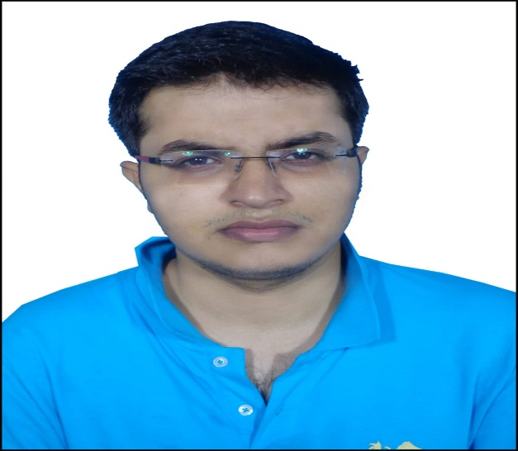**Faculty Profile Template**

1. **Basic Information**

* **Name**: DIVYARTH MANAS
* **Designation**: ASSISTANT PROFESSOR
* **Department/School**: CIVIL ENGINEERING
* **Institution Name**: SSIPMT, RAIPUR
* **Email ID**: divyarth.manas@ssipmt.com
* **Contact Number**: 9470631238

1. **Educational Qualifications**

|  |  |  |  |
| --- | --- | --- | --- |
| **Degree** | **Specialization** | **Institution** | **Year of Completion** |
| UG | Civil | CUSAT | 2015 |
| PG | Structural | SSIPMT | Pursuing (Complete by 2026) |
| Ph.D. |  |  |  |
| Others | *(if applicable)* |  |  |

1. **Teaching & Research Experience**

* **Total Teaching Experience**: 6.5 Years
* **Industry Experience**: 2 Years
* **Research Experience**: NIL

1. **Courses Taught**

* Hydraulic Engineering, Geotechnical Engineering, Hydrology & Water Resources Engineering, Environmental Engineering, Foundation Engineering

1. **Research Interests / Specialization**

* Structural Engineering, Geotechnical Engineering, Water Resources Engineering

1. **Publications (Last 5 Years)**

* Journals – Larhyss Journal (SCOPUS) https://www.scopus.com/inward/record.url?eid=2-s2.0-105008349418&partnerID=MN8TOARS
* Conference Proceedings - NPDSM 2024

1. **Research Guidance**

|  |  |  |
| --- | --- | --- |
| **Level** | **Awarded** | **Ongoing** |
| Ph.D. | NIL | NIL |
| PG | NIL | NIL |

1. **Awards & Recognitions**

* Institutional / National / International - NIL

1. **Administrative Roles**

* Positions held – ACE Coordinator, T&P In charge (Civil), Internship In charge (Civil)

1. **Professional Memberships**

* ISTE

1. **Web Presence**

* Google Scholar -
* ORCID - https://orcid.org/0009-0000-2234-6713