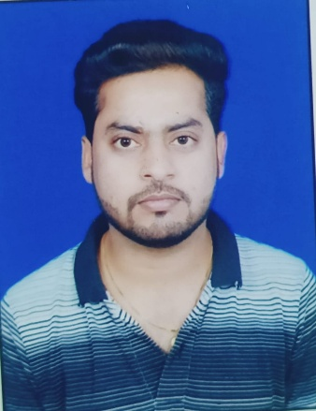**Faculty Profile Template**

1. **Basic Information**

* **Name**: Anant Kumar
* **Designation**: Assistant Professor
* **Department/School**: Civil
* **Institution Name**: Shri Shankaracharya Institute of Professional Management and Technology (SSIPMT), Raipur
* **Email ID**: [anant@ssipmt.com](mailto:anant@ssipmt.com)
* **Contact Number**: 7999712023
* **Photograph**: *(Passport-size, professional)*

1. **Educational Qualifications**

|  |  |  |  |
| --- | --- | --- | --- |
| **Degree** | **Specialization** | **Institution** | **Year of Completion** |
| UG | B.E. (Civil Engineering) | PCEM, Bhilai | 2014 |
| PG | M.Tech in Transportation Engineering | SSTC, Bhilai | 2021 |
| Ph.D. | Civil Engineering | SSIPMT, Raipur | Pursuing 2025 Batch |

1. **Teaching & Research Experience**

* **Total Teaching Experience**: 11 years
* **Industry Experience**:
* **Research Experience**:

1. **Courses Taught**

* List of key UG/PG courses taught: Estimation and costing, Hydraulic structure design, Railway engineering etc.

1. **Research Interests / Specialization**

* Key thematic areas or domains of expertise: Transportation engineering

1. **Publications (Last 5 Years)**

* **Journals (APA/IEEE format)**

1. Kumar, A., Deep, K., Chaturvedi, A., & Ghamforia, S. (2022). Effect of its mechanical properties on concrete mix were sand is partially replaced with industrial ash. *Mathematical Statistician and Engineering Applications*, *71*(4), 9693-9701.
2. Deep, K., Ghamforia, S., Kumar, A., Tamrakar, D., & Manas, D. (2022). Modern Construction Techniques on Concrete In Extreme Weather Conditions. *Mathematical Statistician and Engineering Applications*, *71*(4), 9702-9710.
3. Manas, D., Agrawal, H., Deep, K., Sharma, V., Soni, B., & Kumar, A. (2022). Experimental Analysis of Green Paver Block using Waste Material. *Mathematical Statistician and Engineering Applications*, *71*(4), 9609-9616.

* **Conference Proceedings**

1. Wahane, A., Kumar, A., Dewangan, M., Pandey, M. K., Agrawal, G. K., & Goyal, P. K. (2023, July). Evaluation of the Mechanical and Physical Properties of the Modified Paver Block by Using Waste Plastic Products. In *International Conference on Recent Advances in Mechanical Engineering Research and Development* (pp. 125-137). Singapore: Springer Nature Singapore.
2. Kumar, A., Chandrakar, A., Chandrawanshi, A., Verma, S., & Mishra, A. D. (2025). with Constructional Waste, Industrial. *Advances in Materials Engineering: Select Proceedings of ICFAMMT 2024*, 363.
3. Kumar, A., Shakar, A., Lonhare, M., Verma, B., & Dhruw, H. K. (2024, June). Experimental Analysis of Composite Paver Block Using Bagasse Ash and Crushed Clay Brick. In *Journal of Physics: Conference Series* (Vol. 2779, No. 1, p. 012069). IOP Publishing.
4. Kumar, A., Chopkar, A., Vyas, K., & Suthar, K. (2025). Experiment on Modified Bituminous. *Advances in Materials Engineering: Select Proceedings of ICFAMMT 2024*, 169.
5. Kumar, A., Sahu, N., Sahu, J. K., & Sahu, A. (2023). Experimental investigation of paver block using polypropylene waste and industrial ashes. *Materials Today: Proceedings*, *74*, 808-814.
6. Kumar, A., & Deep, K. (2023). Experimental investigation of concrete with cementitious waste material such as GGBS & fly ash over conventional concrete. *Materials Today: Proceedings*, *74*, 953-961.

* **Book Chapters / Books Authored**

**NIL**

1. **Research Guidance**

|  |  |  |
| --- | --- | --- |
| **Level** | **Awarded** | **Ongoing** |
| Ph.D. | 0 | 0 |
| PG | 0 | 4 |

1. **Awards & Recognitions**

* SIH 2022 Mentor Awardee

1. **Administrative Roles**

* Admission Coordinator

1. **Professional Memberships**
2. **Web Presence**

* Google Scholar - <https://scholar.google.com/citations?user=OqKDXfUAAAAJ&hl=en>
* ResearchGate - <https://www.researchgate.net/institution/Shri-Shankaracharya-Institute-of-Professional-Management-and-Technology/members>
* ORCID- <https://orcid.org/0000-0002-6663-6971?lang=en>